I am Robayat Hasan. I was born in Jamalpur but grown up in Comilla. I have completed HSC from Barkota school and college. I am currently studying Computer Science Engineering at Daffodil University. I like to spend some time gaming. I mean gaming is my hobby.

I want to be a software engineer in the future. I have a lot of interest in learning something new. I like to think about creativity in every moment.

I am a running student at Daffodil International University. Section-B, Student ID: 202-15-14421.

**Daffodil International University**

**Computer Science and Engineering**

**2020-2024**

Reading

Writing

Music

Photography

01633221144

robayat15-14421@diu.edu.bd

**EDUCATION**

**HOBBIES**

**CONTACT**

**PROFILE**

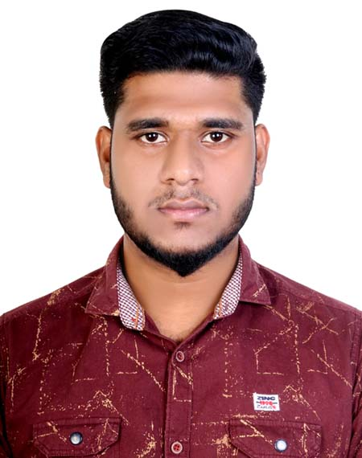

**ROBAYAT HASAN**

**Barkota School and College**

**Group science**

**2017-2019**

391-mail4.png

I have completed HSC from Barkota school and college.

**Lalpur Nazrul Islam High School**

**Group science**

**2015-2016**

I have completed SSC from Lalpur Nazrul Islam High School

067-phone.png

001-home.png

Binodtongi, Madargonj, Jamalpur

202-sphere.png

[**https://infallible-sinoussi-aa06bd.netlify.app/**](https://infallible-sinoussi-aa06bd.netlify.app/)

**Additional activities**

032-book.png016-camera.png

**I have completed HTML, CSS & Bootstrap from bohubrihi, I can do some programming languages like Java, C Programming, C ++,**

**data structures & algorithms.**

006-pencil.png018-music.png

**BIO-DATA**

**1. Name : Robayat Hasan**

2. Fathers Name : MD. Belal Uddin

3. Mothers Name : Rektha Begum

4. Permanent Address : Vill:Binodtongi, P.O: Binodtongi, P.S:Madargonj, Dist:Jamalput.

5. Present Address : Vill: Mohammadpur, P.o: Mohammadpur. P.S: Mohammadpur, Dist:Dhaka.

H#6, R#5 , Kaderabag Housing.

6. Contact No : 01633221144

7. Date of Birth : 18 Aug 2001

8. Nationality : Bangladeshi

9. Religion : Islam

10. Marital Status : Single

11. Sex : Male

**12. Education Qualification :**

|  |  |  |  |  |  |
| --- | --- | --- | --- | --- | --- |
| Name of Exam | Passing Year | G.P.A | Group | Institute | Board |
| S.S.C | 2017 | 3.77 | Science | Lalpur Nazrul Islam High School | Cumilla |
| H.S.C | 2019 | 4.67 | Science | Borkota School and Collage | Cumilla |

.

Date : 24-11-2021 Robayat

**Signature**